***Experiment 8***

***Prolog Code:***

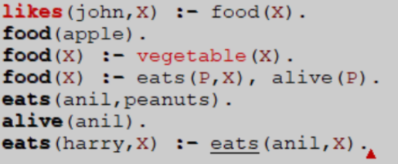

***Resolution Graph:***

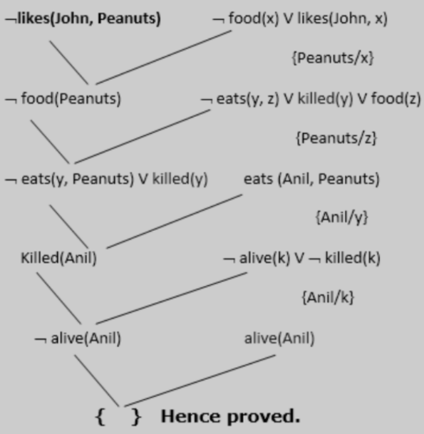

***Output:***



